Mobile App Performance Testing

For any mobile app, performance is very critical. If your Mobile App does not perform well, the end user will uninstall your app find another application that performs better. Mobile application needs to be tested thoroughly before releasing it to end user.

# **Mobile Application Testing Strategy:**

Application performance on a mobile phone or any smart device is usually measured in following three categories.

* Device Performance
* Server/API Performance
* Network Performance

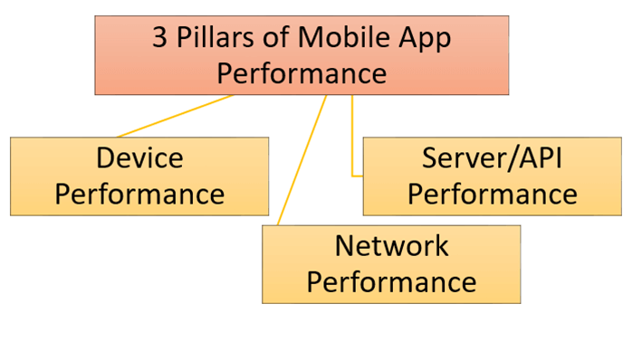

## **1) Device Performance:**

For device performance, you will check the following:

### **App Start Up:**

How much time your app takes to start up? It is the first performance parameter adjudged by the user. As a thumb rule, after the user taps on app icon the first screen should be shown in 1-2 seconds.

### **Battery Time while using an app:**

On constant use, some mobile apps, consume a high amount of battery life and heat the phone. This factor adds a lot to the performance of any mobile app and could normally happen when your app is using more resources than required. Excessive resource usage creates a burden on the processor and phone gets heat up.

### **Memory Consumption:**

When Testing an app, the memory consumption by an app should be checked. By implementing certain functionalities in the app, the memory consumption also increases. For example, in Android apps when push notifications are implemented then memory consumption increases.

In some cases, it has been observed that memory usage by whole O.S is mere 14%, but a new app is consuming 11%. So, these factors must be handled before deploying the app to the real world or giving to the client.

### **Hardware/Software Variation:**

When testing a mobile app, it is mandatory to check apps on different devices. It could be the case that app is running smooth on one device but not on other. Like for different vendors of Android devices, we can check the app on Samsung, HTC, and Lenovo phones. Similarly, the app needs to be tested with different RAM and processor specifications like 1 GB or 2 GB.

### **Usage with Other Apps:**

When the app under test is running in parallel with other apps, there should be no interference. The best way to check it is by switching app under testing and other apps.

### **App in background:**

An app that is running in the background is retrieved, it should remain in the same state as it was before. If this scenario is not handled properly, then data get lost. Again, you should enter data from scratch upon retrieving the app.

## **2) Server/API Performance:**

When the app is interacting with the server via API, the response time becomes critical to performance. For Server performance, you will check -

### **Data to and from server:**

The app should handle data efficiently that is sent from the server. It must not take too much time while loading data. In certain apps, data is sent in a specified format. So before displaying it in the app, it should be converted to a relevant format. In this process, apps sometimes become slower and response time becomes longer.

### **API Calls Generated from App:**

The number of calls from App under test to the server generated from app should be less. In some cases, multiple API calls are made for the same functionality. For better performance, this should be handled with less number of calls.

### **Server Down Time:**

Due to any reason if the server is down or unreachable we can save data in the native database. So, whenever the server is down, we can show data stored in the native database. Another solution could be the failover database servers i.e. if one of the servers is down or in maintenance phase the backup server should be available to switch over. The failover/backup server should be in continuous replication and synchronization with the main server.

## **3) Network Performance:**

The performance of the app on different networks and network properties need to be measured.

### **Jitters:**

When there is a delay in receiving information on the network, then it is termed as jitters. It is a problem with the connectionless networks or packet switch networks. As the information is distributed into packets, packets can travel by a dissimilar path from the sender to the receiver. When data arrives at the intended location, it becomes scrambled than it was originally sent. In the case of Jitters, the mobile app should be capable enough to handle it.

You need to Show the appropriate notifications to the end user, either to resend the request or wait till the system responds again.

### **Packet Loss:**

In the case of complete packet loss, the app should be able to resend the request for the information or should generate the alerts accordingly. If data is not complete, then the user will not be able to comprehend information displayed in App. This can be stressful for the user. So, it is better to display a suitable message or prompt user to try again.

### **Network Speed:**

The app needs to be checked on a variety of networks with variable speed. The app should be tested on 2.5G, 3G, and 4G networks. Both Wi-Fi and mobile networks are included in this. Also, the behavior of app should be monitored. Especially, when both networks are available, and switching occurred from one network to another.

For example, an issue may arise in an app for the users while switching phone network from 4G to WIFI and vice versa. In this case, the app becomes unresponsive and may require restarting the app for use.

# **Troubleshooting Mobile App Performance:**

**1) Lag or sluggish response of the Mobile App:**

The cause of this delay may be the RAM, Cache, etc.

* You need to kill unnecessary processes or clear the cache. Troubleshooting the connectivity issue may solve some of the problems that are creating lags.

**2) App Restarting, locking up, freezing or unresponsiveness:**

It may be fixed by some of the following steps

* Optimizing the application codes.
* Software should be patched and updated.
* Automatic restores.
* Managing RAM or in some cases ROM while using external cards.
* Wiping the cache partitioning.
* Verifying the app working with other third-party apps and API's.
* Mapping the mobile application according to device.

## **Challenges:**

Key challenges faced while performance testing include:

* Organizing different mobile platforms and their operating systems.
* Simulating Connectivity like Edge, 3G, 4G or Wi-Fi, etc.
* Mobile devices constraints like battery and resources consumption.
* Mobile phone usability.
* The assorted sizes of mobile devices to run the same app.

## **Set up Mobile App Performance Test Environment:**

To configure Test Environment, you need to-

* Understanding of the mobile app which needs to be tested.
* Identification of different OS on which the app needs to run.
* Building the test setup.
* Build the emulators or simulators.
* Prototyping of the actual setup.
* Selecting the appropriate tool for the testing.

## **Mobile App Performance Testing Checklist:**

Testing the performance of the mobile apps is an important measure before release. Performance testing is done to check:

* How much of the RAM is required for utilizing this app?
* To verify speed and response time of APP under different networks and circumstances.
* Ensure realistic user experience under several network conditions.
* Ensure the required results are achieved in case of multiple connectivity.
* Ensure the application do not get crashed.
* Ensuring the mobile applications perform well while using data, Wi-Fi or other connectivity.
* Monitoring the uptime and the mobile API usage bottlenecks.
* To ensure the maximum number of simultaneous users.
* Finally, to check the mobile app to its limits.